SQL PROJECT 2

-- Joining Tables:

-- 1. Retrieve the full name of artists along with the names of the museums where their works are displayed.

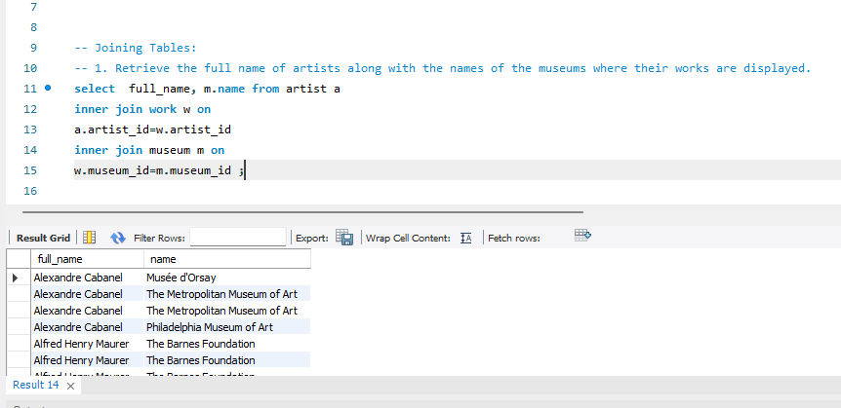

-- 2. Group By and Count:

-- How many works does each artist have in the database? Display the artist's full name along with the count of their works, ordered by the count in descending order.

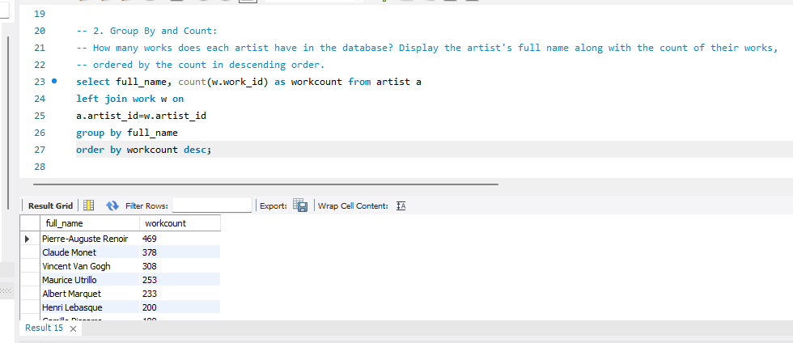

-- 3. Order By and Limit:

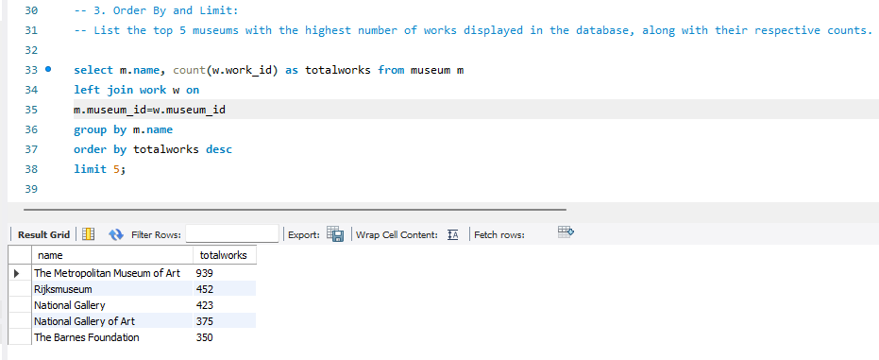-- List the top 5 museums with the highest number of works displayed in the database, along with their respective counts.

-- 4. Join, Order By, and Limit:

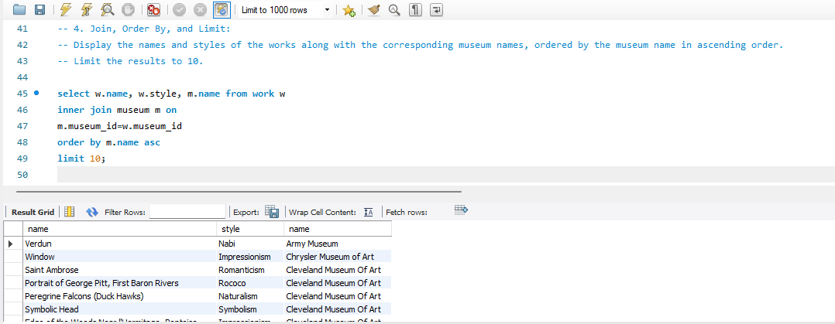-- Display the names and styles of the works along with the corresponding museum names, ordered by the museum name in ascending order. Limit the results to 10.

-- 5.Join, Group By, and Sum:

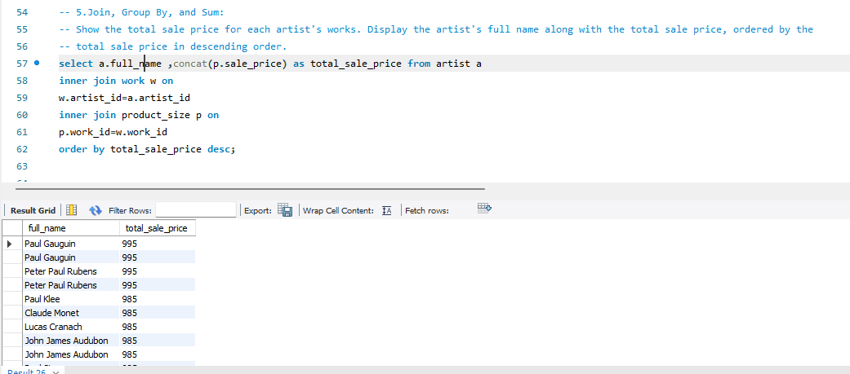-- Show the total sale price for each artist's works. Display the artist's full name along with the total sale price, ordered by the total sale price in descending order.

-- 6. Join, Group By, and Having:

-- List artists who have more than 3 works in the database, along with the count of their works.

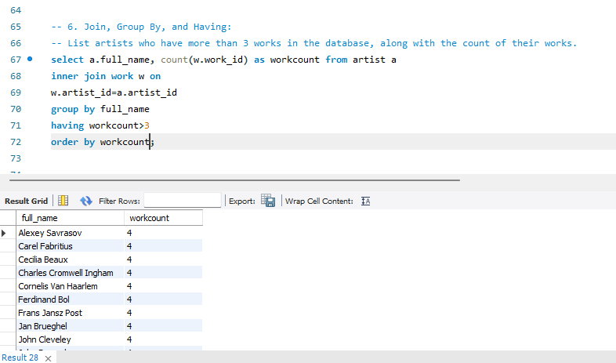

-- 7. Join, Where, and Order By:

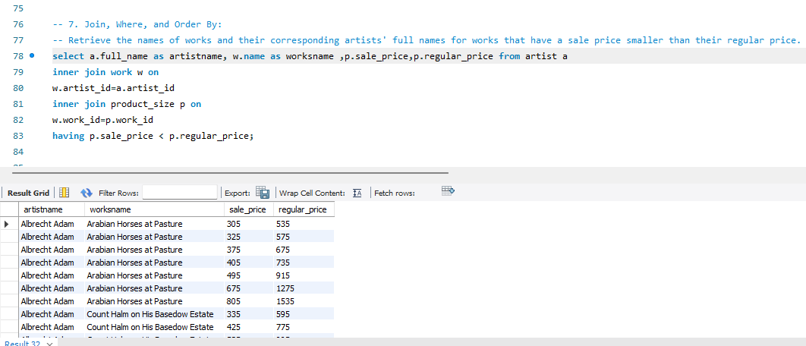-- Retrieve the names of works and their corresponding artists' full names for works that have a sale price smaller than their regular price.

-- 8. Join, Group By, and Average:

-- Calculate the average height and width of the artworks in the database. Display the average height and width.

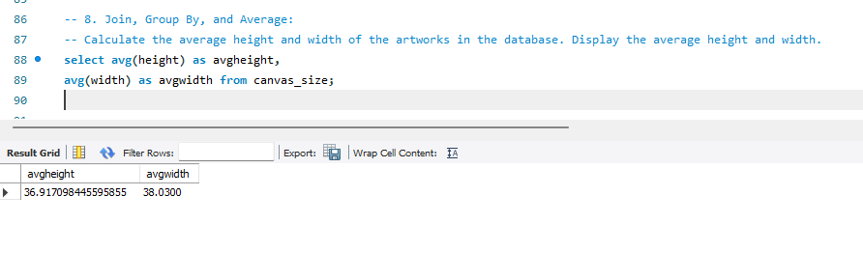

-- Join, Group By, and Max:

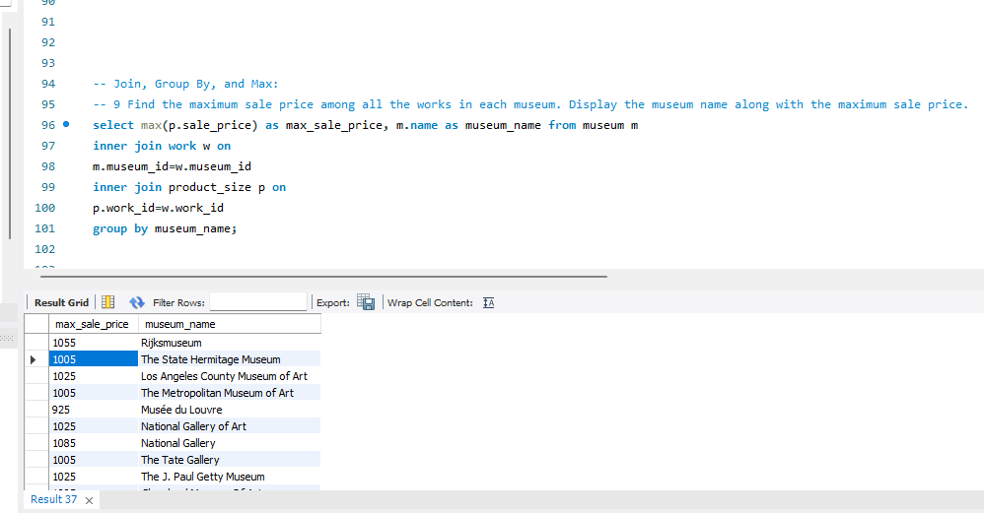-- 9 Find the maximum sale price among all the works in each museum. Display the museum name along with the maximum sale price.

-- Join, Group By, and Concatenate:

-- 10. Concatenate the first name and last name of artists along with their nationality, separated by a comma. Display the concatenated string along with the count of works by each artist, ordered by the count in descending order.

